LIHEAP Benefit Calculation (Maximum Benefit)

- Determine the household income

♣ The income amount that will be used in this example will be $2,650

- Determine 100% of poverty level for the household size

♣ The household size of four (4) will be used in this example.

OFFICE OF MANAGEMENT AND BUDGET (OMB) 100% POVERTY LEVELS
- Divide income by 100% of poverty level for a household with four (4) physical bedrooms.

- $2,650/$32,150 = .082 Multiply the figure by 100 to calculate the percent of poverty

♣ .082 x 100 = 8.2 or 8.2% of Poverty

- Determine Income/Heating Degree Day (HDD) multipliers for the sub-grantee’s service area using the percent of poverty previously calculated.

♣ The Income/Heating Degree Day Multiplier for District 7 is .9 for 8.2% of poverty.

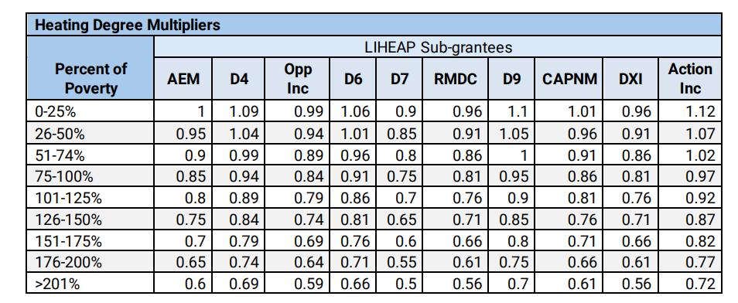

- Identify the dwelling type (Single Family)
- Identify number of eligible bedrooms (Four),
- Identify the fuel type (Fuel Oil)
- Determine the base benefit using the base benefit matrix.

♣ The base benefit for a single-family dwelling, with four physical bedrooms and a fuel type of fuel oil would be $3,362.

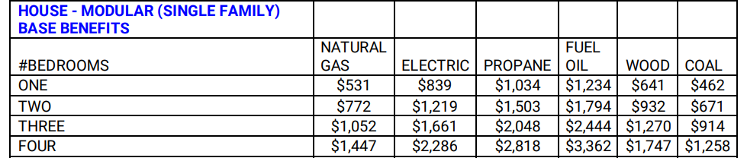

- Multiply the base benefit amount $3,362 by .9 (Income/HDD multiplier, #5 above) to find the LIHEAP benefit.

♣ $3,362 x .9 = $3,025.8 rounded to $3,026

LIEAP Benefit Calculation (Minimum Benefit)

- Determine the household income

♣ The income amount that will be used in this example will be $29,796

- Determine 100% of poverty level for the household size

♣ The household size of one (1) will be used in this example.

OFFICE OF MANAGEMENT AND BUDGET (OMB) 100% POVERTY LEVELS

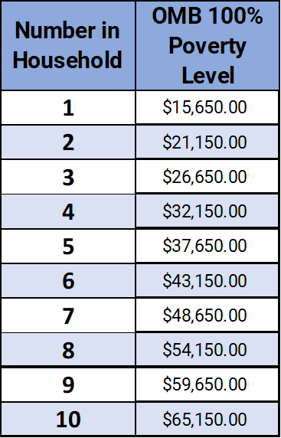
- Divide income by 100% of poverty level for a household size of one.

- $29,796/$15,650 = 1.90 Multiply the figure by 100 to calculate the percent of poverty

♣ 1.90 x 100 = 190% of Poverty

- Determine Income/Heating Degree Day (HDD) multipliers for the sub-grantee’s service area using the percent of poverty previously calculated.

♣ The Income/Heating Degree Day Multiplier for District 7 is .55 for 197% of poverty.

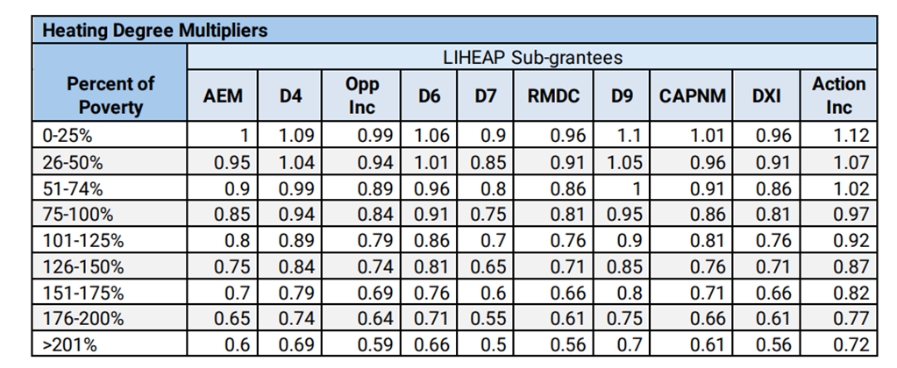

INCOME/HEATING DEGREE DAY MULTIPLIERS

- Identify the dwelling type (Multi-Family)
- Identify number of physical bedrooms (1),
- Identify the fuel type (Coal)
- Determine the base benefit using the base benefit matrix.

♣ The base benefit for a Multi-Family dwelling, with one (1) physical bedroom and a fuel type of coal would be $328.

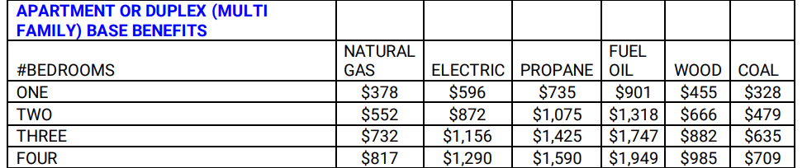

- Multiply the base benefit amount $328 by .55 (Income/HDD multiplier) to find the LIHEAP benefit.
♣ $328 x .55 = $180.4

